Preface

This Guide covers the handling of transfer letters of credit in Trade Innovation. It assumes that you are familiar with the basic principles of trade finance relating to letters of credit, and with web browsers.

# About Transfer Letters of Credit

Transferable letters of credit are created as normal letters of credit. Check the Transferable field to indicate that the letter of credit is transferable.

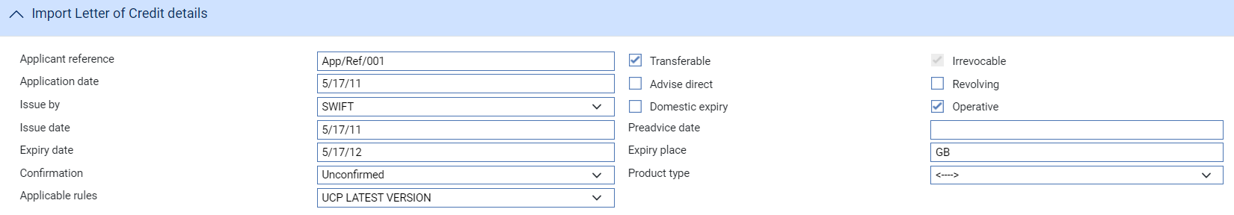

The Partial Shipments field must be any value other than 'Not Allowed' if you wish to create more than one transfer letter of credit against the parent, or if payments to the transferee and the first beneficiary are to be made separately.

Once this parent letter of credit has been released, you can create any number of transfer letters of credit against it, which will be settled using the proceeds of the parent letter of credit. Transfer letters of credit must be within the terms of the original letter of credit, and the sum of all transfer letters of credit cannot exceed the value of the parent letter of credit.

The beneficiary of the parent letter of credit is termed the first beneficiary, and the beneficiary of the transfer letter of credit termed the second beneficiary. The principal for the transfer letter of credit is generally the first beneficiary, but may be the issuer of the original letter of credit.

A transfer letter of credit is created on the instructions of the first beneficiary, who can specify that, when documents are presented, the first beneficiary's invoices should be substituted for those presented by the second beneficiary. The default values for 'buyer' and 'seller' in the transfer letter of credit are determined by the way that your bank has set up your system - see the System Tailoring User Guide – Trade Innovation for more information.

Once created, a transfer letter of credit appears in the Master browser window and can be opened independent of the parent letter of credit. However, any processing of the transfer letter of credit, such as amendments, payment and expiry, is initiated from within the parent letter of credit. There is no separate Book Off event for a transfer letter of credit. Book off is processed via the parent letter of credit.

The Master Summary window for the parent letter of credit contains a Splits button, which you can use to list any transfer letters of credit entered against it and view details of them. Conversely, the Master Summary window for the transfer letter of credit includes an extra button - Export LC for export letters of credit, Import LC for import letters of credit - which you can use view details of the parent letter of credit.

## Transferring an Import LC

Transfer letters of credit are typically handled within export letters of credit as requests from the beneficiary in the exporter’s country.

Where an import letter of credit is processed as a domestic LC you can also transfer an import LC to a second beneficiary.

The process for handling a transfer LC is identical between the import LC and export LC products so is described only once within this guide.

## Charges

Charges may be set for a transfer letter of credit from the parent letter of credit, or for the transfer letter of credit using the Update Event charge window. Select the 'Other' option from the Charge For field.

# Creating a Transfer Letter of Credit

## How to Create a Transfer Letter of Credit

To create a transfer letter of credit, in the Master Summary window for the parent letter of credit, select the Team and then select 'Transfer' or 'Transfer ILC' from the Create New Event drop-down list. The system opens the event at either a Log step or Input step (see page 5), depending on how the Workflow orchestration controlling the event is configured. See the *Workflow Tailoring User Guide – Trade Innovation* for details.

Logging a Transfer Letter of Credit

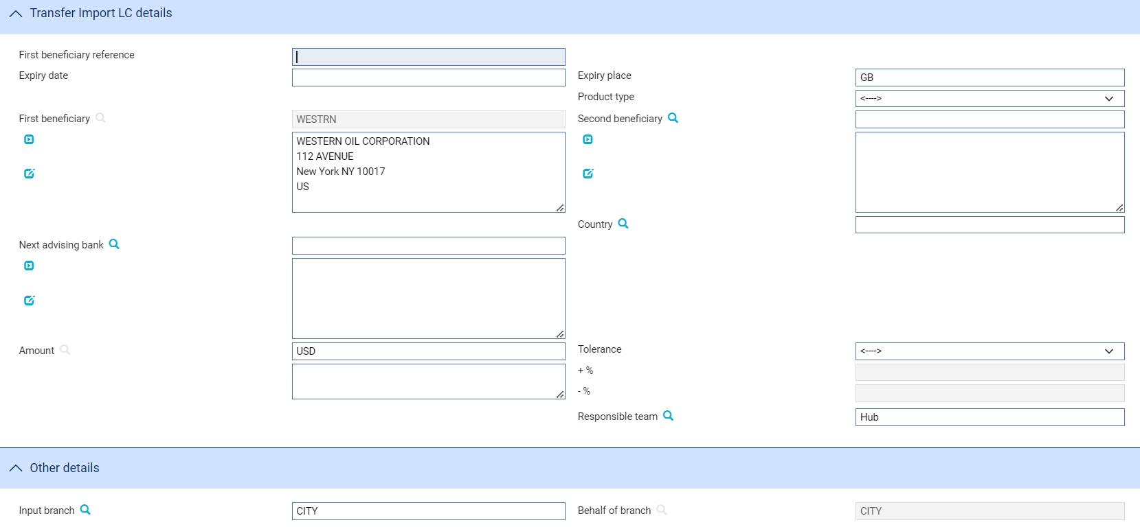

The following table explains what to enter into the fields in this window:

|  |  |  |
| --- | --- | --- |
| Field | What to Enter | |
| First Beneficiary Reference | The applicant's reference for the letter of credit, taken from their application. | |
| Expiry Date | The expiry date of the transfer letter of credit. This must be the same day as, or earlier than, the expiry date of the parent letter of credit. | |
| Expiry Place | The location at which the expiry date applies. | |
| Product Type | If your bank has set up product types for transfer letters of credit, select the appropriate one from the drop-down list on this field. | |
| First Beneficiary | The first beneficiary. | |
| Second Beneficiary | The second beneficiary. | |
| Country | The second beneficiary’s country of residence. | |
| Next Advising Bank | The next advising bank. | |
| Amount | The amount and currency of the transfer letter of credit. The system displays the amount and currency in the language of your system beneath these fields. You can edit this text, if necessary. | |
| Available By | Used to define the tenor - see the Common Facilities User Guide – Trade Innovation for instructions. | |
| Tolerance | Specify how the amount is being expressed. Select from one of the following: | |
|  | Exact | If the amount is the exact value of the letter of credit. |
|  | About | If the amount given in the Amount field is within 10% either way of the expected value of the letter of credit. |
|  | Other | If you select this option, use the -% and +% fields to specify as a percentage how much more or less than the final value of the letter of credit the amount entered is allowed to be. |
|  | Not Exceeding | If the final value of the letter of credit is expected to be no more than the amount entered, and not less than 95% of the amount entered. |
|  | Min/Max | If you select this option the system displays a + Amount and a - Amount field. Use them to specify as an amount how much more or less than the final value of the transaction the amount entered is allowed to be. |
| Input Branch | The input branch for the transaction. The input branch is set from either :   * the accounting branch from the user’s team, or * the transaction branch for user if the user has a default transaction branch or is locked to a specific branch, or * a branch associated with the user where the user can enter transactions for several branches for a team | |
| Responsible Team | The team that has overall responsibility for the master e.g. as the contact to resolve any queries or issues regarding the master and associated events. The system defaults the responsible team when creating the transaction as follows:   * Manual – set from team creating the transaction * Gateway – set from the team specified on the incoming message (if present and valid) otherwise to the team to which the transaction is assigned through workflow allocation based on the behalf of branch * SWIFT – set to the team to which the transaction is assigned through workflow allocation based on the behalf of branch   It can be changed, if required, to either the team associated with the primary customer, default team for the product or the user’s current team. | |
| Behalf of Branch | The behalf of branch for the transaction as entered by the user or set from the incoming SWIFT or gateway message. The behalf of branch determines the parameter sets that are to be used to generate charges, documents, postings, etc. during transaction processing. The branch can be changed to any other branch within the same main banking entity that shares the same parameter sets. | |
| Related Reference | You can specify the reference of any other transaction to which this letter of credit is related. This may already have been done when the master record was created. You can use the browser to select from possible references to include. | |

### Entering Full Details of a Transfer Letter of Credit

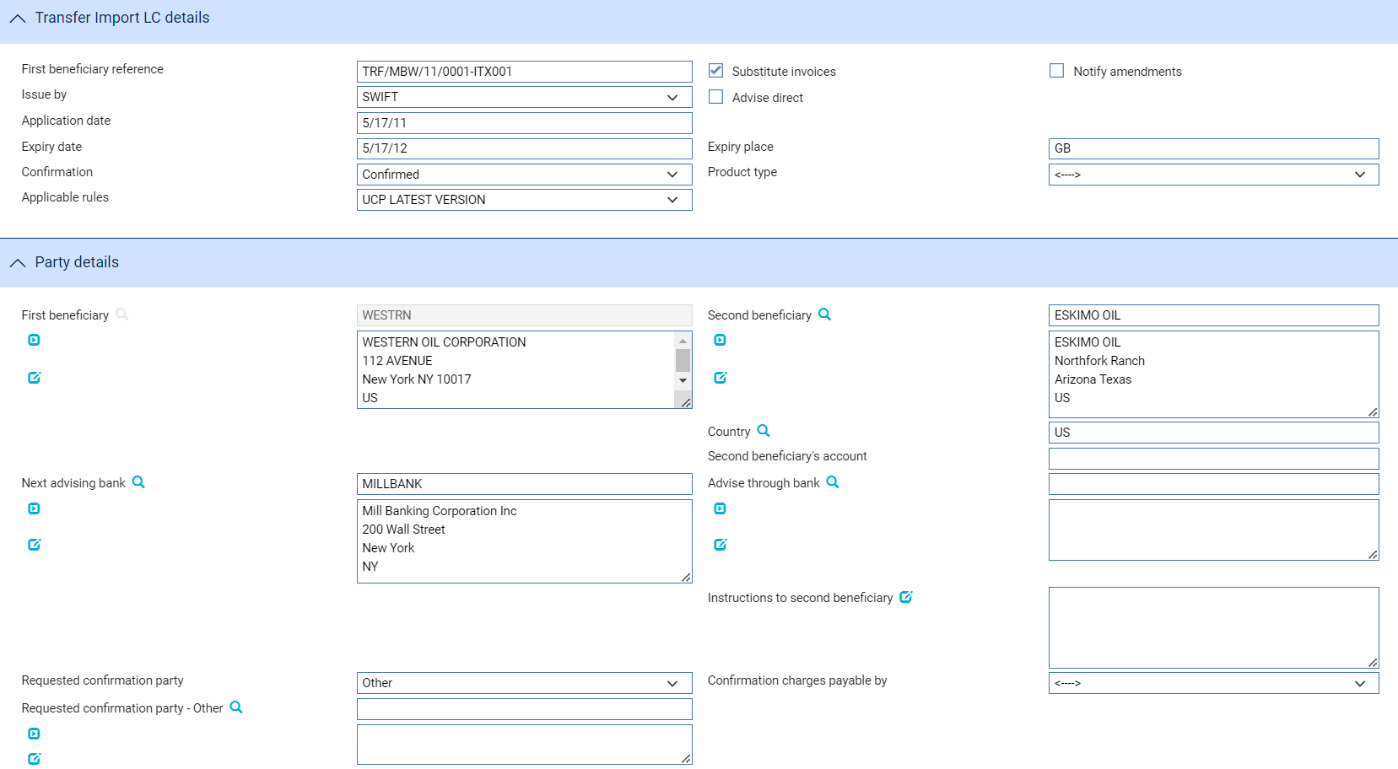

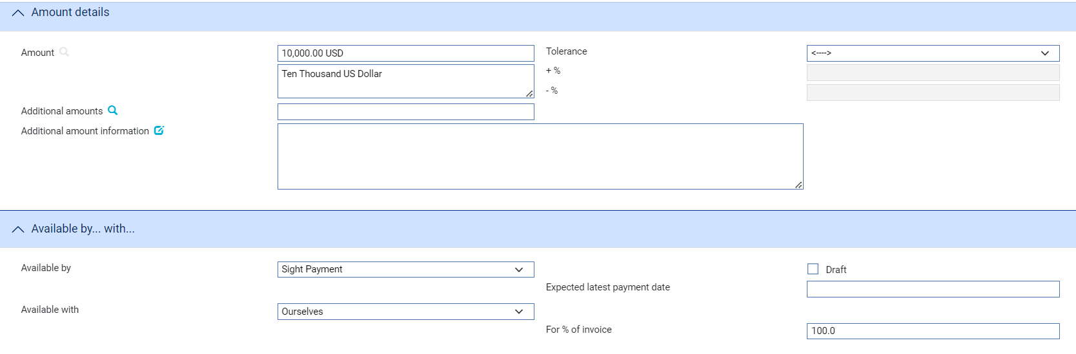

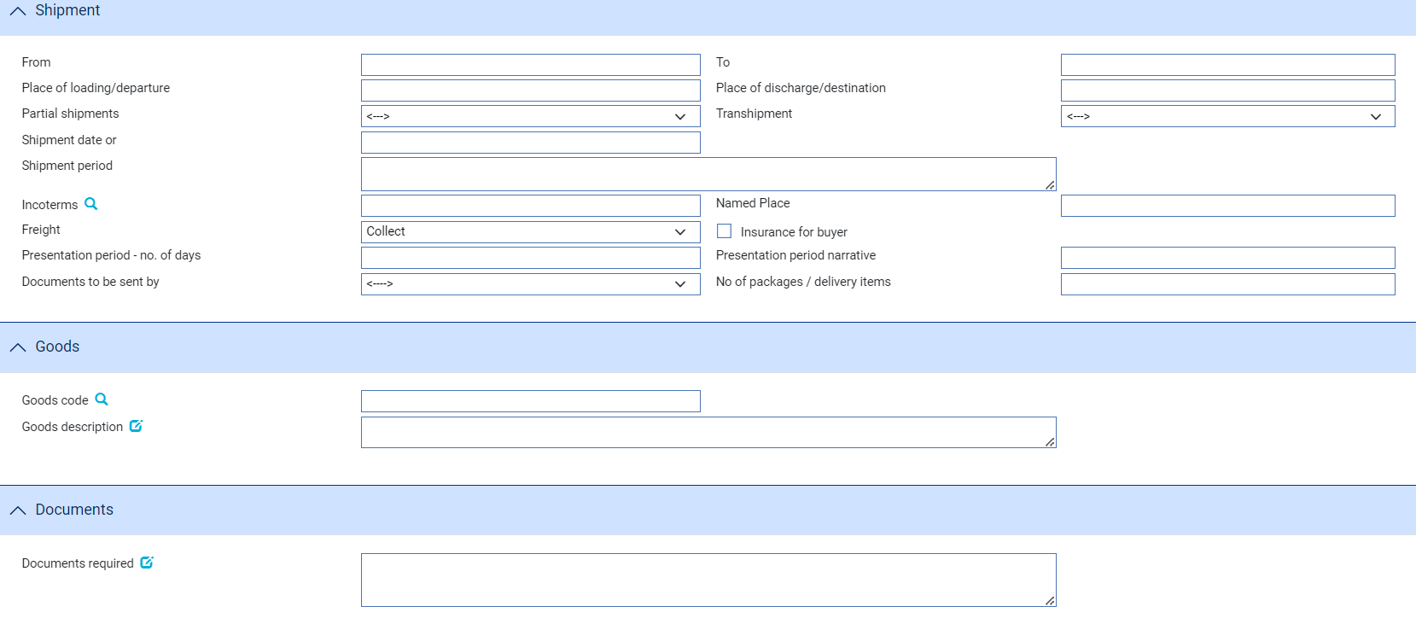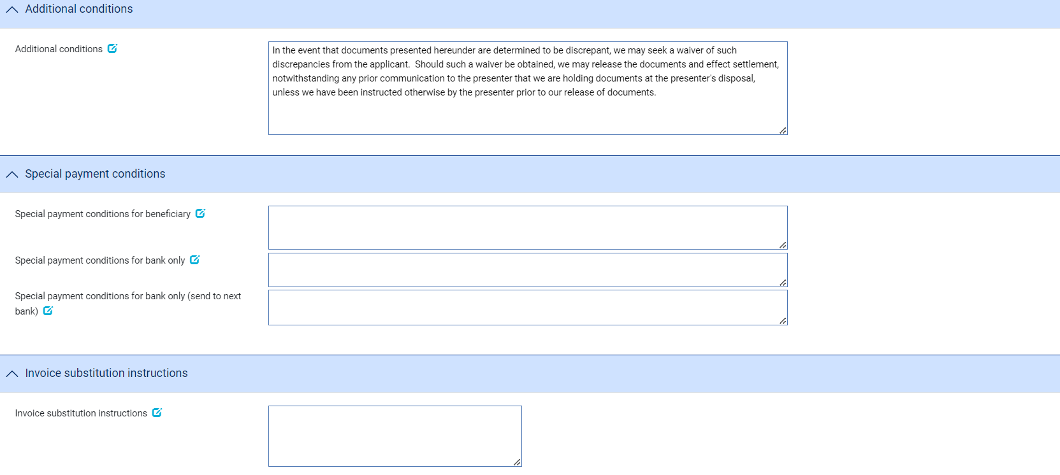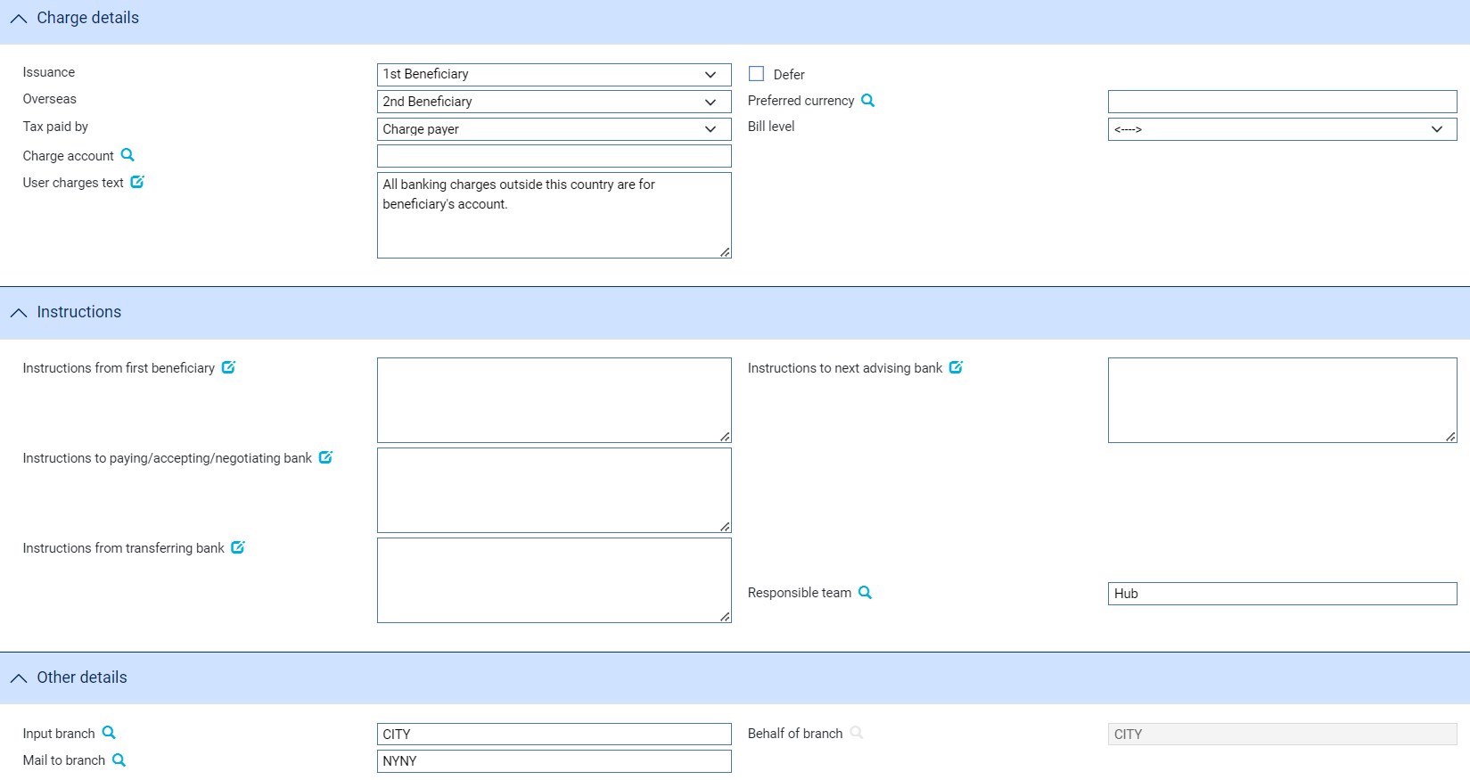

The window used during an Input step has the following panes:

* The Transfer Export LC Details Pane (see page 6) or the Transfer Import LC Details Pane (see page 6)
* The Party Details Pane (see page 7)
* The Amount Details Pane (see page 9)
* The Available By/With Pane (see page 9)
* The Shipment Pane (see page 10)
* The Goods Pane (see page 11)
* The Documents Pane (see page 11)
* The Additional Conditions Pane (see page 12)
* The Special Payment Conditions Pane (see page 12)
* The Invoice Substitution Instructions Pane (see page 12)
* The Charge Details Pane (see page 13)
* The Instructions Pane (see page 13)
* The Other Details Pane (see page 14)

The Transfer Export/Import LC Details Pane

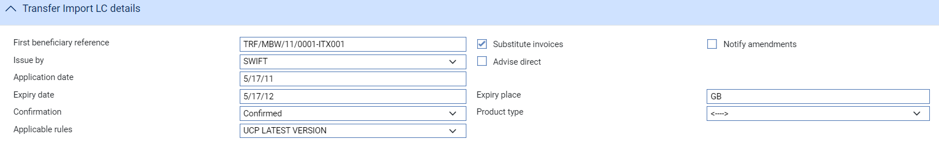

The following table explains what to enter into the fields in the Transfer Export LC Details or Transfer Import Details pane:

|  |  |  |  |
| --- | --- | --- | --- |
|  | Field | What to Enter | |
|  | First Beneficiary Reference | The first beneficiary's reference for the transfer letter of credit. | |
|  | Substitute Invoices | Check this box if the first beneficiary's invoices are to be substituted for those of the second beneficiary when a claim is made. | |
|  | Notify Amendments | Check this box if the second beneficiary is to be notified of any amendments to the parent letter of credit. | |
|  | Issue By | The method of transmission to be used to send the letter of credit. If you leave this field blank the system will use the method specified in the address details for the recipient of the letter of credit. | |
|  | Advise Direct | Check this field if the credit is being advised directly to the beneficiary. | |
|  | Application Date | The date your bank received the application for the transfer letter of credit. | |
|  | Expiry Date | The expiry date of the transfer letter of credit. This must be the same day as, or earlier than, the expiry date of the parent letter of credit. | |
|  | Expiry Place | The location at which the expiry date applies. | |
|  | Confirmation | Select from one of the of the following values: | |
|  | | Confirmed | If you want the advising bank to confirm the letter of credit. |
|  | | Unconfirmed | If you do not want the advising bank to confirm the letter of credit. This is the default value. |
|  | | May Add | If you have no preference whether they confirm the letter of credit or not. |
|  | Product Type | If your bank has set up product types for transfer import letters of credit, select the appropriate one from the drop-down list on this field. Depending on how your system has been configured, this field may be mandatory. | |
|  | Applicable Rules | This allows you to select additional information to be included in the SWIFT MT720 message generated by the event.  Select one of the following to indicate the rules applied to the issue of the documentary credit: | |
|  |  | UCP LATEST VERSION  The documentary credit is subject to the version of the ICC Uniform Customs and Practice for Documentary Credits, International Chamber of Commerce, Paris, that is in effect on the date of issue.  This is used as the default. | |
|  |  | EUCP LATEST VERSION  The documentary credit is subject to the version of the Supplement of the ICC Uniform Customs and Practice for Documentary Credits for Electronic Presentations, International Chamber of Commerce, Paris, that is in effect on the date of issue. | |
|  |  | UCPURR LATEST VERSION  The documentary credit is subject to the version of the ICC Uniform Customs and Practice for Documentary Credits and the version of the Uniform Rules for Bank-to-bank Reimbursements under documentary credits, International Chamber of Commerce, Paris, that is in effect on the date of issue. | |
|  |  | EUCPURR LATEST VERSION  The documentary credit is subject to the version of the Supplement of the ICC Uniform Customs and Practice for Documentary Credits for Electronic Presentations and the version of the Uniform Rules for Bank-to-bank Reimbursements under documentary credits, International Chamber of Commerce, Paris, that is in effect on the date of issue. | |
|  |  | ISP LATEST VERSION  For standby letters of credit only. The documentary credit is subject to the version of the ICC International Standby Practices, International Chamber of Commerce, Paris, that is in effect on the date of issue. | |
|  |  | OTHR  The documentary credit is subject to other rules. Use the Other Applicable Rules field to specify those rules (up to 35 characters). | |
|  | Other Applicable Rules | Displayed only if you select OTHR in the previous field. | |

#### The Party Details Pane

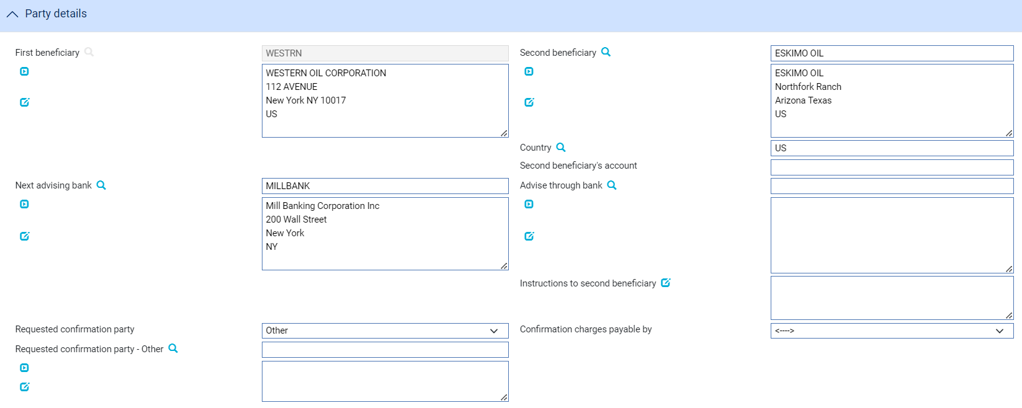

The following table explains what to enter into the fields in the Parties pane:

|  |  |  |  |
| --- | --- | --- | --- |
|  | Field | What to Enter | |
|  | First Beneficiary | The system displays the details of the first beneficiary here. These are taken from the parent letter of credit and cannot be amended. | |
|  | Second Beneficiary | The second beneficiary. | |
|  | Country | The second beneficiary’s country of residence. | |
|  | Second Beneficiary’s Account | The account information that you enter here for the second beneficiary is used to populate the Second Beneficiary field (tag 59) on an MT720. | |
|  | Next Advising Bank | Identify the next advising bank. | |
|  | Advise Through Bank | Identify the advise through bank, if appropriate. | |
|  | Confirmed By | Select one of the following options: | |
|  |  | Blank | The default value for this field. |
|  |  | Next Advising Bank | If you want the next advising bank to add its confirmation or may add its confirmation. |
|  |  | Advise Through Bank | If you want the advise through bank to add its confirmation or may add its confirmation. |
|  |  | OTHER | If you want other bank to add its confirmation or may add its confirmation. |
|  |  | This field is displayed and mandatory when confirmation is set to CONFIRMED or MAYADD. | |
|  | Requested Confirmation Party | The name and address of the bank which is requested to add its confirmation or may add its confirmation.  This field is displayed and mandatory when Confirmed By is set to Other. | |
|  | Confirmation Charges Payable By | Select from one of the following options: | |
|  |  | Blank | The default value for this field. |
|  |  | Applicant | If you want the applicant to be responsible for payment of confirmation charges |
|  |  | Beneficiary | If you want the beneficiary to be responsible for payment of confirmation charges |
|  |  | This field is displayed and mandatory when confirmation is set to CONFIRMED or MAYADD. | |

#### The Amount Details Pane

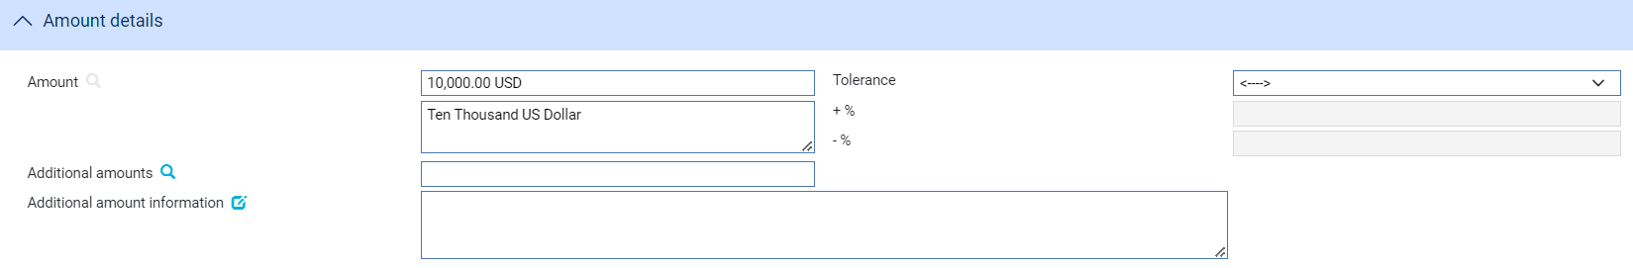

The following table explains what to enter into the fields in the Amount Details pane:

|  |  |  |
| --- | --- | --- |
| Field | What to Enter | |
| Amount | The amount and currency of the transaction. The system displays the amount and currency in the language of your system beneath these fields. You can edit this text, if necessary. | |
| Tolerance | Specify how the amount is being expressed. Select from one of the following: | |
|  | Exact | If the amount is the exact value of the letter of credit. |
|  | About | If the amount given in the Amount field is within 10% either way of the expected value of the letter of credit. |
|  | Other | If you select this option, use the -% and +% fields to specify as a percentage how much more or less than the final value of the letter of credit the amount entered is allowed to be. |
|  | Not Exceeding | If the final value of the letter of credit is expected to be no more than the amount entered, and not less than 95% of the amount entered. |
|  | Min/Max | If you select this option the system displays a + Amount and a - Amount field. Use them to specify as an amount how much more or less than the final value of the transaction the amount entered is allowed to be. |
| Additional Amounts | Any amounts payable to the beneficiary in addition to the principal amount of the transaction. These might include, for example, local freight charges.  If you enter an amount, it is added to the amount of liability under the transaction. If you use a different currency for the amount, then the amount is converted to the currency of the transaction using the current spot rate. | |
| Additional Amount Details | A text description of what any additional amounts are for. | |

#### The Available By/With Pane



The following table explains what to enter into the fields in the Available By/With pane:

|  |  |  |
| --- | --- | --- |
| Field | What to Enter | |
| Available By/Draft | Used to set the tenor of the payment. See the Common Facilities User Guide – Trade Innovation for instructions. | |
| Available With | Select from one of the following to indicate which party the beneficiary should present documents for payment to:   * Ourselves * Issuing Bank * Advising Bank * Any Bank * Any Bank in (city) – the system displays a field, into which you can enter the name of the city * Any Bank in (country) – the system displays a browser which you can use to select the country * (named bank) – the system displays fields which you can use to specify the bank   Additional fields may be displayed, depending on what you have selected: | |
|  | Country | If Available With is set to 'Any Bank in Country' identify the country. |
|  | City | If Available With is set to 'Any Bank in City' identify the city. |
|  | Named Bank | If Available With is set to 'Named Bank' identify the bank. |
| For % of Invoice | The percentage of the invoice value of the goods that the letter of credit covers. The system uses 100% as the default value. | |

#### The Shipment Pane

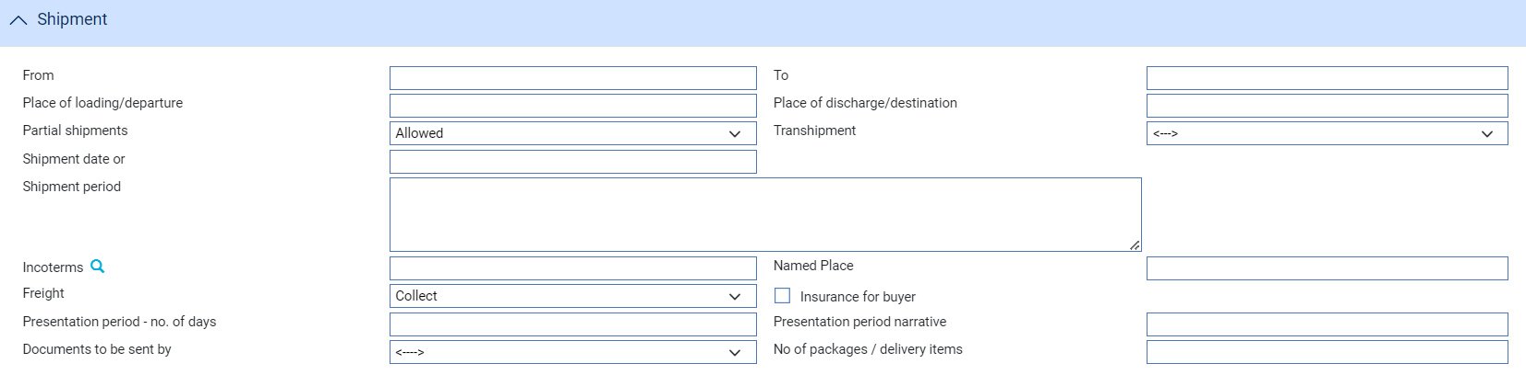

The following table explains what to enter into the fields in the Shipment pane:

|  |  |  |
| --- | --- | --- |
| Field | What to Enter | |
| From | The place of taking in charge of the goods. | |
| To | The final destination of the goods. | |
| Place of Loading/ Departure | The port or airport where the goods were loaded. | |
| Place of Discharge/ Destination | The port or airport for which the goods are destined. | |
| Partial Shipments/ Transhipments | Select one from the following values: | |
|  | Blank | To leave the field blank in the associated SWIFT message. |
|  | Allowed | If partial shipments/transhipments are permitted for this letter of credit. |
|  | Not Allowed | If partial shipments/transhipments are not permitted for this letter of credit. |
|  | Conditional | If selected then the user should specify conditions in the Additional conditions narrative. |
| Shipment Date | The latest shipment date allowed. | |
| Shipment Period | Specify the period of time during which goods are to be loaded or despatched. | |
| Incoterms | Select incoterms. | |
| Freight | When you select a value in the Incoterms field, the system automatically selects the appropriate value in this field using information set up for the selected incoterms to indicate whether freight is to be pre-paid or paid on collection. You can override this value. | |
| Insurance for Buyer | When you select a value in the Incoterms field, the system automatically selects the appropriate value in this field using information set up for the selected incoterms to indicate whether the buyer is to provide insurance cover or not. The field is checked if insurance cover is to be provided by the buyer. You can override the value displayed here. | |
| Presentation Period/Presentation Period Narrative | Specify the number of calendar days after the date of shipment within which the documents must be presented for payment, acceptance or negotiation. Narrative must only be used to specify another type of date than a shipment date, for example invoice date, from which the period for presentation begins.  A default value is set automatically; calculated using the latest shipping date and the expiry date, but this default can be overridden. | |
| Documents to be Sent By | The method to be used to send documents. | |
| No of Packages/Delivery Items | Specify how many mailings are to be made. | |

#### The Goods Pane

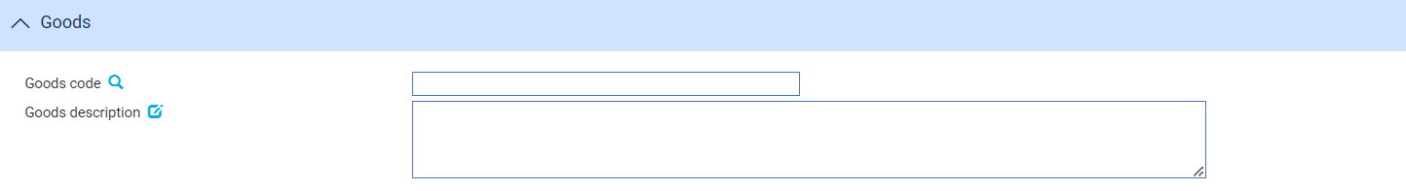

The Goods pane allows you to select a code for the goods and enter a description of the goods.

The Documents Pane



Use the field in the Documents Required pane to enter a narrative description of any documents required to support the transaction.

#### The Additional Conditions Pane



Use the field in the Additional Conditions pane to enter a narrative description of any additional conditions.

#### The Special Payment Conditions Pane

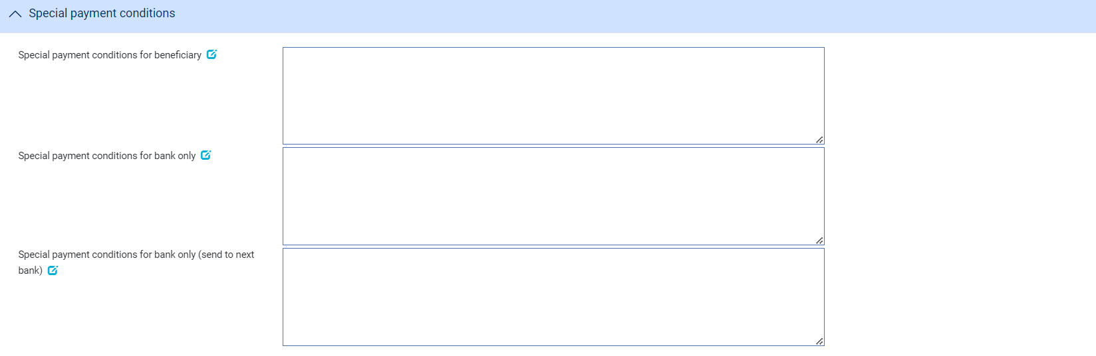 The following table explains what to enter into the fields in the Special Payment Conditions pane:

|  |  |
| --- | --- |
| Field | What to Enter |
| Special payment conditions for beneficiary | Specify special payment conditions applicable to the beneficiary of the credit. |
| Special payment conditions for bank only | Specify special payment conditions applicable to the receiving bank of the credit without disclosure to the beneficiary. |
| Special payment conditions for bank only (send to next bank) | Specify special payment conditions applicable to the next bank. |

#### The Invoice Substitution Instructions Pane

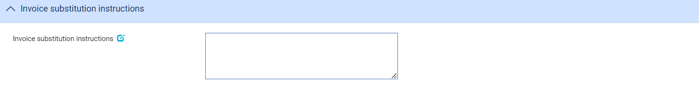

If the first beneficiary's invoices are to be substituted for that of the second beneficiary, enter any additional instructions here.

#### The Charge Details Pane

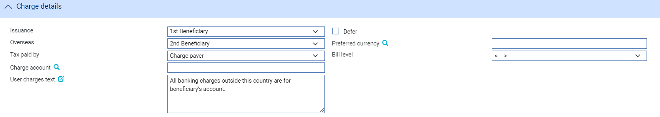

The following table explains what to enter into the fields in the Charge Details pane:

|  |  |
| --- | --- |
| Field | What to Enter |
| Issuance | Specify which party - the first beneficiary or the second beneficiary - will pay your bank's issuance charges. |
| Defer | Indicate whether your own charges are to be collected now or deferred until payment. Check this box if the charges are to be deferred, otherwise leave it blank. |
| Overseas | Specify which party - the first beneficiary or the second beneficiary - will pay overseas charges. |
| Preferred Currency | The currency in which your bank's own charges will be collected. Typically, you would set this to your local currency. If you leave this field blank, the system uses the currency of the letter of credit.  Where the charges are for the applicant, the setting here is overridden by the applicant's preferred currency. |
| Tax Paid By | Specify which party - your customer or the party liable for charges - will pay any tax due on the letter of credit or its charges. |
| Bill Level | Select whether charges for this license should be billed at customer level, transaction level or product level. |
| Charge Account | The number of the account used for any charges debited to the customer. Charge accounting is normally controlled by the standing settlement instructions for charges. Entering an account number here overrides the account specified in the standing settlement instructions. |
| User Charges Text | Any additional information about charges due. |

#### The Instructions Pane

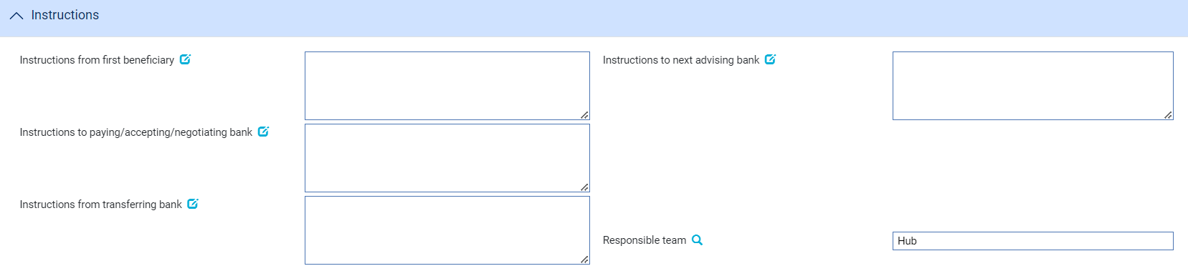

The following table explains what to enter into the fields in the Instructions pane:

|  |  |
| --- | --- |
| Field | What to Enter |
| Instructions from First Beneficiary | Instructions received from the first beneficiary with the application for a transfer letter of credit. |
| Instructions to Next Advising Bank | Any instructions for the next advising bank. |
| Instructions to Paying/accepting/ negotiating Bank | Any instructions for the paying/accepting/negotiating bank. |
| Instructions from transferring bank | Any instructions from the transferring bank. |

#### The Other Details Pane



The following table explains what to enter into the fields in the Other Details pane:

|  |  |
| --- | --- |
| Field | What to Enter |
| Input Branch | The input branch for the transaction. The input branch is set from either:   * the accounting branch from the user’s team, or * the transaction branch for user if the user has a default transaction branch or is locked to a specific branch, or * a branch associated with the user where the user can enter transactions for several branches for a team |
| Behalf of Branch | The behalf of branch for the transaction as entered by the user or set from the incoming SWIFT or gateway message. The behalf of branch determines the parameter sets that are to be used to generate charges, documents, postings, etc. during transaction processing. The branch can be changed to any other branch within the same main banking entity that shares the same parameter sets. |
| Mail to Branch | The mail to branch can be set to any branch within the main banking entity of the behalf of branch. |
| Responsible Team | The team that has overall responsibility for the master e.g. as the contact to resolve any queries or issues regarding the master and associated events. The system defaults the responsible team when creating the transaction as follows:   * Manual – set from team creating the transaction * Gateway – set from the team specified on the incoming message (if present and valid) otherwise to the team to which the transaction is assigned through workflow allocation based on the behalf of branch * SWIFT – set to the team to which the transaction is assigned through workflow allocation based on the behalf of branch   It can be changed, if required, to either the team associated with the primary customer, default team for the product or the user’s current team. |

## Once You have Completed the Transfer Letter of Credit

The master record for the transfer letter of credit is created once the Transfer or Transfer ILC event has been released. Upon release the system creates the reference for the master, and the transfer letter of credit is included in the Masters browser. The Master Summary window for the parent letter of credit shows details of the transfer letter of credit.

If the event requires review and/or authorisation, then it will be listed in the Work in Progress pane until it has been released. The expiry date for the transfer letter of credit appear in the Diary pane in the Master Summary window for the transfer itself and for its parent letter of credit.

The parent Master Summary window includes a Splits button, which allows you to display details of transfer letters of credit set up against the parent letter of credit.

In the transfer letter of credit’s Master Summary window an Export LC or Import LC button is present and opens the Master Summary window for the parent letter of credit.

Processing of the transfer letter of credit is carried out from within the parent letter of credit. When you open an event to process a transfer letter of credit, the event will include a Select or Select Transfer button. This opens a window that lists all the transfer letters of credit set up for the parent letter of credit, and permits you to select the one you wish to work on.

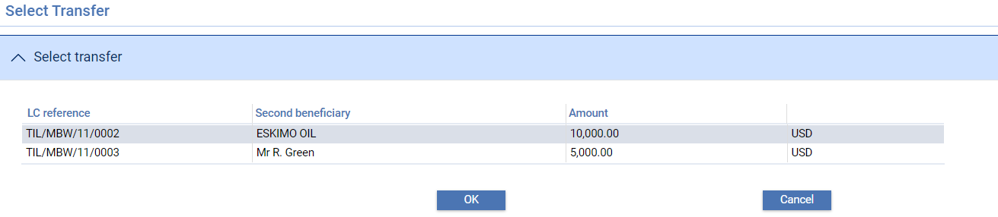

### Entering Details of an Acknowledgement

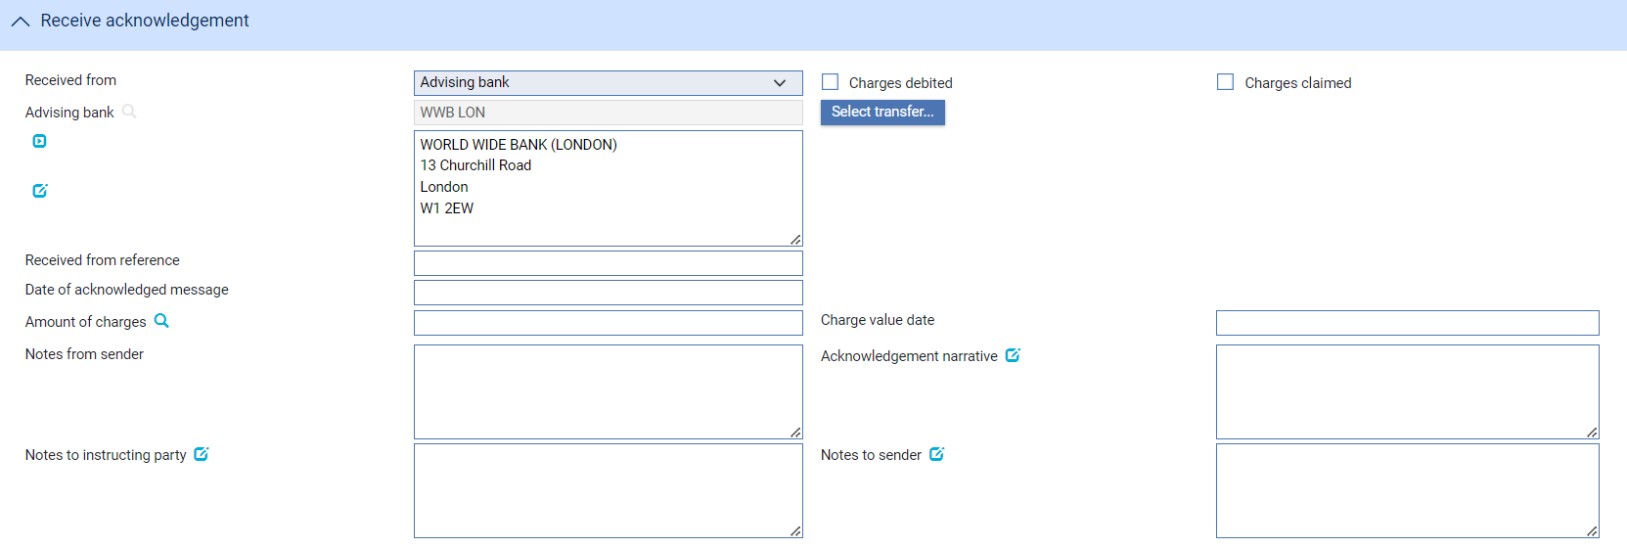

Details of an acknowledgement you have received are entered using a Transfer - Receive Acknowledgement event. The event uses the same window for the Log and Input steps. Depending on how your system is configured, panes and fields available in log steps can be tailored for each data capture step. See the *SDK - Screen Tailoring Guide – Trade Innovation* for details.

Use the Received From field to enter the role of the party from whom you have received the acknowledgement, and the Received From Reference field to enter that party's reference for the transaction. In the Sender to Receiver and Acknowledgement Narrative field, enter any narrative associated with the response.

If appropriate, check either the Charges Claimed box or the Charges Debited box to indicate whether the advising bank is claiming its charges or has debited its charges. You cannot check both of these boxes, but you can leave them both blank.

Use the narrative field to enter any details advised by the acknowledgment received from party.

# Paying a Transfer Letter of Credit

Payment of import transfer letters of credit and export transfer letters of credit is handled using the normal payment events. Payment can be handled in one of two ways:

* You can pay a letter of credit on its own, independent of its parent letter of credit, and receive reimbursement in the normal way from the issuer
* You can use the same claim event to process the parent letter of credit and an associated transfer letter of credit. This allows the first beneficiary's invoices to be substituted for those of the second beneficiary. The second beneficiary is then paid from the proceeds arising from the claim made to the issuing bank by the first beneficiary, with any excess going to the first beneficiary

You can process payment of only one transfer letter of credit within a single sequence of claim events, regardless of whether you are paying it independent of or at the same time as its parent letter of credit.

## Paying an Export Transfer Letter of Credit

To pay a transfer letter of credit independent of the parent letter of credit, in the Master Summary window for the parent letter of credit select 'Documents Presented' from the Create New Event drop-down list then click **Create**. The system creates a Documents Presented event at either a Log step or Input step (see page 17), depending on how the Workflow orchestration controlling the event is configured. See the *Workflow Tailoring User Guide – Trade Innovation* for details.

### Where There is More than One Transfer Letter of Credit

If there is only one transfer letter of credit for this master then the details of it are automatically retrieved and displayed; if there are more than one, you must select the one you wish to pay by clicking on the Select Transfer button.

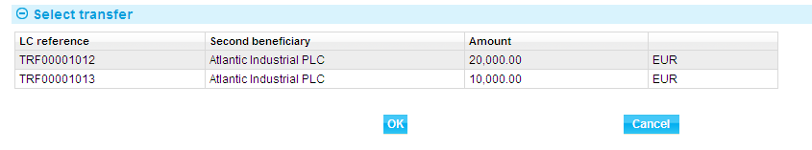

This displays a window that lists all the transfer letters of credit set up for this letter of credit. Highlight the appropriate one, then click **OK**. You can subsequently use the Select Transfer button in a Log or Input window to select a different transfer letter of credit.

#### Logging the Payment

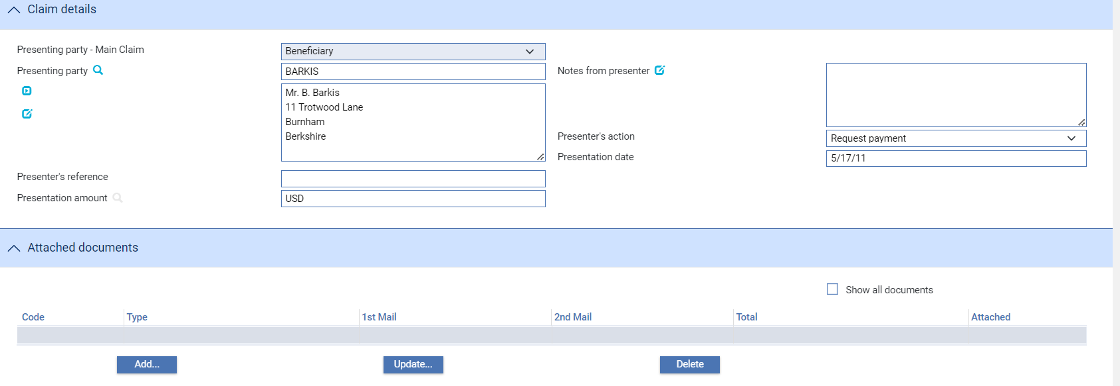

Identify the presenting party, enter details of the amount to be paid, and enter details of any documents presented.

1. The system uses the advising bank as presenter of the transfer letter of credit by default, rather than the second beneficiary.

### Entering Full Details of the Payment

If there is only one transfer letter of credit for this master then the details of it are automatically retrieved and displayed; if there are more than one, you must select the one you wish to pay by clicking on the Select Transfer button (see page 20).

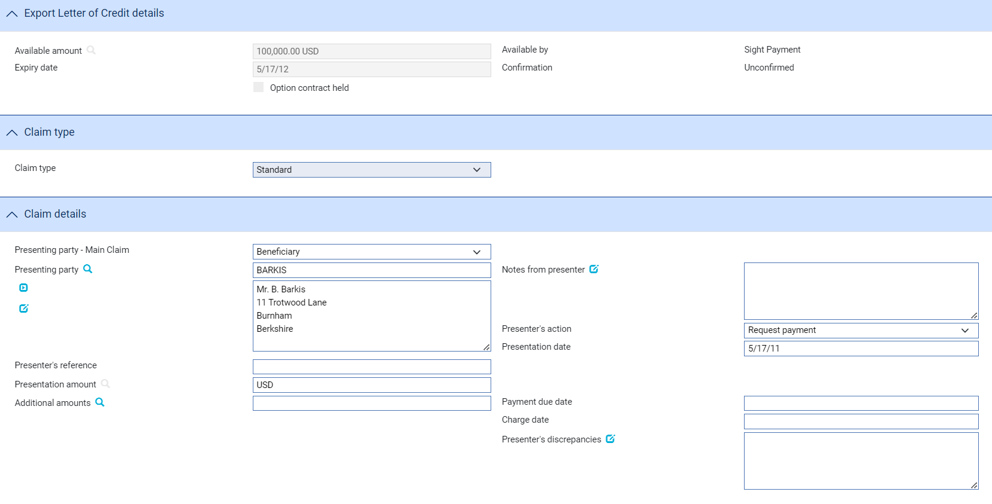 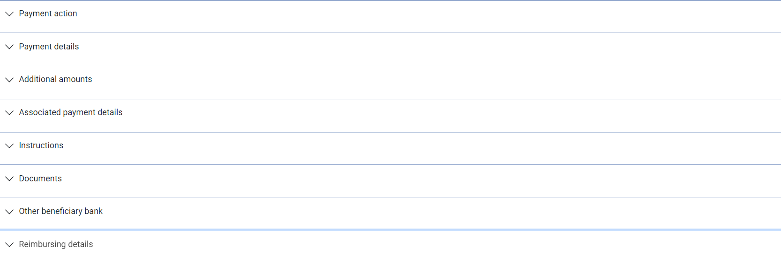

Use the Claim Type fields to select whether you wish to pay:

* The parent letter of credit only – select ‘Standard’
* The transfer letter of credit only - select 'Transfer Only'
* The parent letter of credit and the transfer letter of credit - select 'Invoice Subst'

If you select anything other than 'Standard' in the Select required Claim Type field then if there is only one transfer letter of credit for this master then the details of it are automatically retrieved and displayed in the Transfer Claim Details pane; otherwise you must select the one you wish to pay by clicking on the Select Transfer button (see page 20).

Where you are paying the transfer letter of credit only, enter details for the payment into the Transfer Claim Details pane as for a normal Documents Presented event.

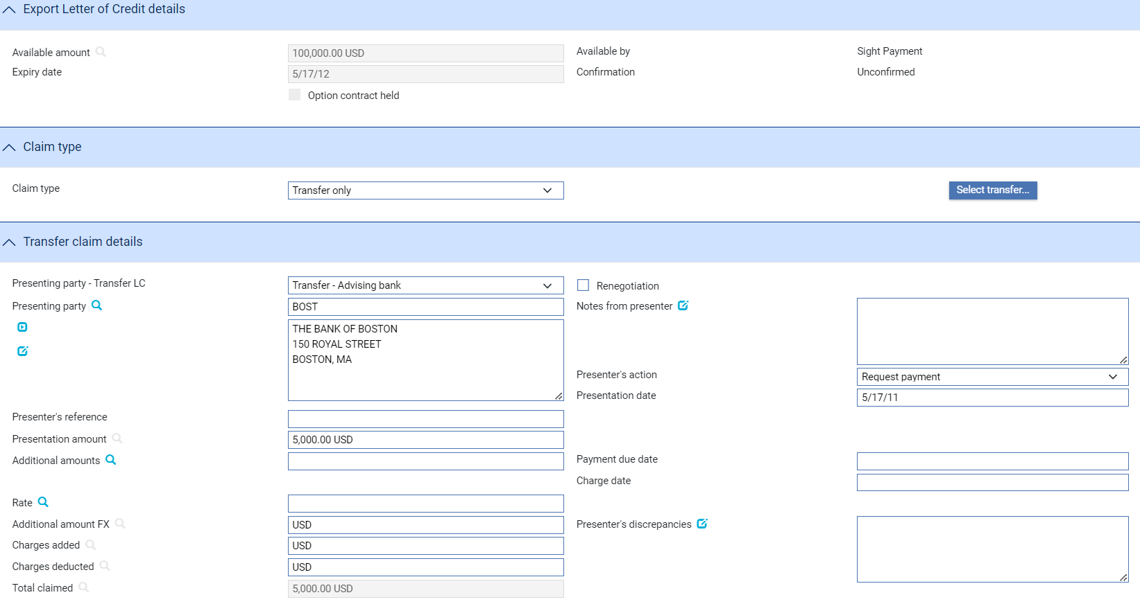 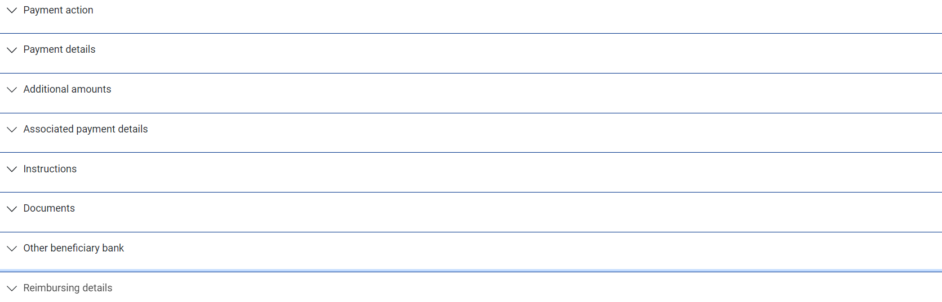

1. The system uses the advising bank as presenter of the transfer letter of credit by default, rather than the second beneficiary.

If you select 'Invoice Subst' the window changes to display a Transfer Claim Details pane for you to enter details of the transfer letter of credit payment, and a Main Claim Details pane for you to enter details of the payment against the parent letter of credit.

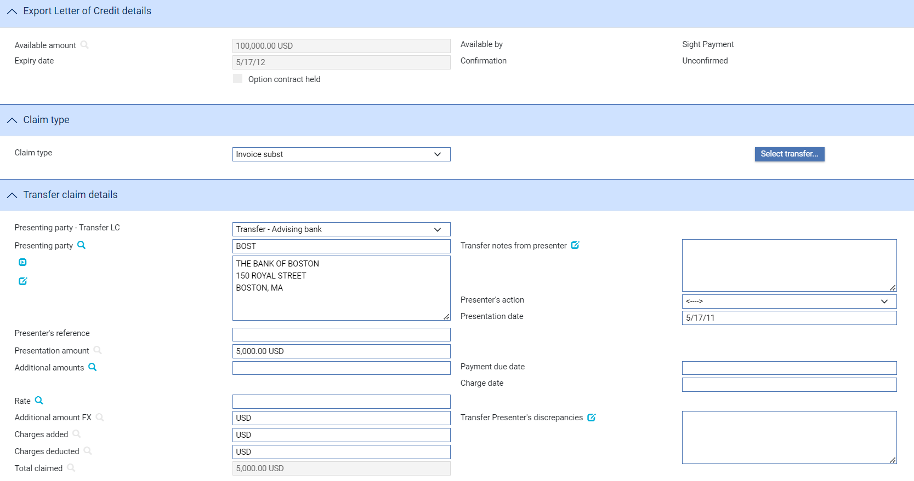 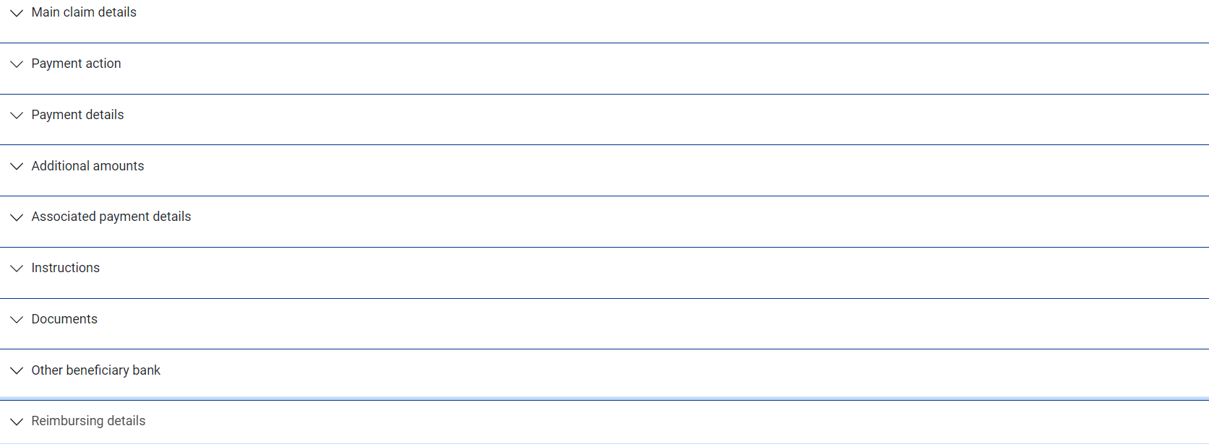 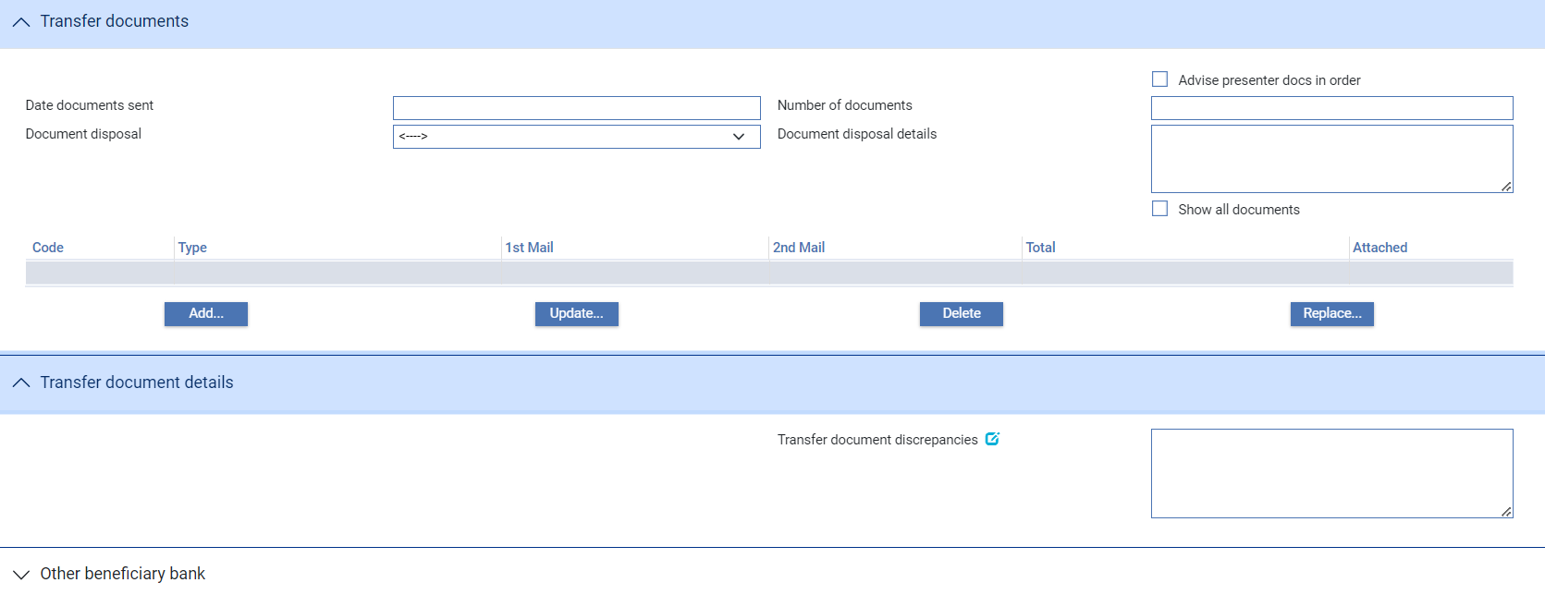

For the transfer letter of credit use the Other Beneficiary Bank field to identify the party the presenter of the transfer letter of credit wants you to pay (if other than the presenter); and the Account field to identify the number of the account to be credited in favour of the bank identified in the Other Beneficiary Bank field.

When processing a claim involving invoice substitution two additional payment actions are available:

* ‘Await Replacement Invoices’, which allows you to enter details of the transfer claim during an initial Documents Presented event, and details of the first beneficiary’s claim during a subsequent or Outstanding Presentation event
* ‘Pay from Suspense’, which allows you to enter details of the transfer claim and make payment to the transfer presented from a suspense account during the initial Documents Presented event. You can then enter details of the first beneficiary’s claim during a subsequent Outstanding Presentation event, when the transfer portion of the funds received from the issuer are used to clear the suspense account

If you select either of these actions, then, once the first beneficiary’s invoices have been received, you can use an Outstanding Presentation event to complete the claim, selecting as your payment action ‘Invoices Received’.

1. The system is delivered with a standard set of ‘Presenter’s actions’ and ‘Payment actions’ which will typically cover the required processing for claims and documentary presentations. However, depending on your bank’s internal processes and requirements, it may be necessary to create additional Presenter’s and Payment actions that are more appropriate to your workflow for transfer letters of credit.

Where this is required, your bank can use System Tailoring to define its own Parameter set based Presenter's actions and Payment actions for Import letters of credit and additionally, create Transfer presenter's actions and Response actions as required. A code and description can be entered for each of these actions together with the associated underlying payment ‘behaviour’ type, such as *General request, Pay, Reject, or Pay at maturity* which then determines the subsequent processing of the payment when the action is selected.

See the System Tailoring Guide – Trade Innovation for instructions on defining additional payment actions.

## Paying an Import Transfer Letter of Credit

To pay a transfer letter of credit independent of the parent letter of credit, in the Master Summary window for the parent letter of credit select ‘Claim Received’ from the Create New Event drop-down list then click **Create**. The system creates a Claim Received event at either a Log step or Input step (see page 20), depending on how the Workflow orchestration controlling the event is configured. See the *Workflow Tailoring User Guide – Trade Innovation* for details.

### Where There is More Than One Transfer Letter of Credit

If there is only one transfer letter of credit for this master then the details of it are automatically retrieved and displayed; if there are more than one, you must select the one you wish to pay by clicking on the Select Transfer button.

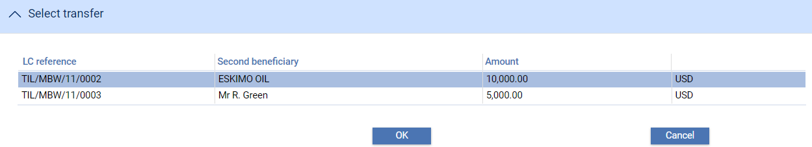

This displays a window that lists all the transfer letters of credit set up for this letter of credit. Highlight the appropriate one, then click **OK**. You can subsequently use the Select Transfer button in a Log or Input window to select a different transfer letter of credit.

#### Logging the Payment

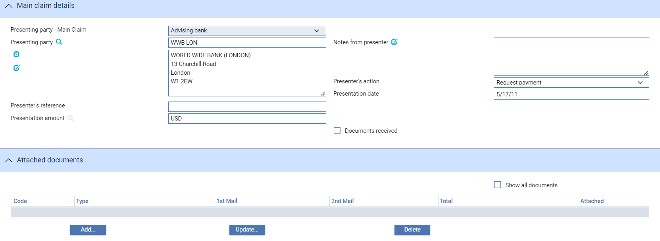

Identify the presenting party, enter details of the amount to be paid, and enter details of any documents presented.

1. The system uses the advising bank as presenter of the transfer letter of credit by default, rather than the second beneficiary.

### Entering Full Details of the Payment

Use the Claim Type fields to select whether you wish to pay:

* The parent letter of credit only – select ‘Standard’
* The transfer letter of credit only - select 'Transfer Only'
* The parent letter of credit and the transfer letter of credit - select 'Invoice Subst'

If there is only one transfer letter of credit for this master then the details of it are automatically retrieved and displayed in the Transfer Claim Details pane; otherwise you must select the one you wish to pay using the Select Transfer button (see page 20) that appears.

Identify the presenting party, enter details of the amount to be paid, and enter details of any documents presented.

1. The system uses the advising bank as presenter of the transfer letter of credit by default, rather than the second beneficiary.

Where you are paying the transfer letter of credit only, enter details for the payment into the Transfer Claim Details pane as for a normal Claim Received event.

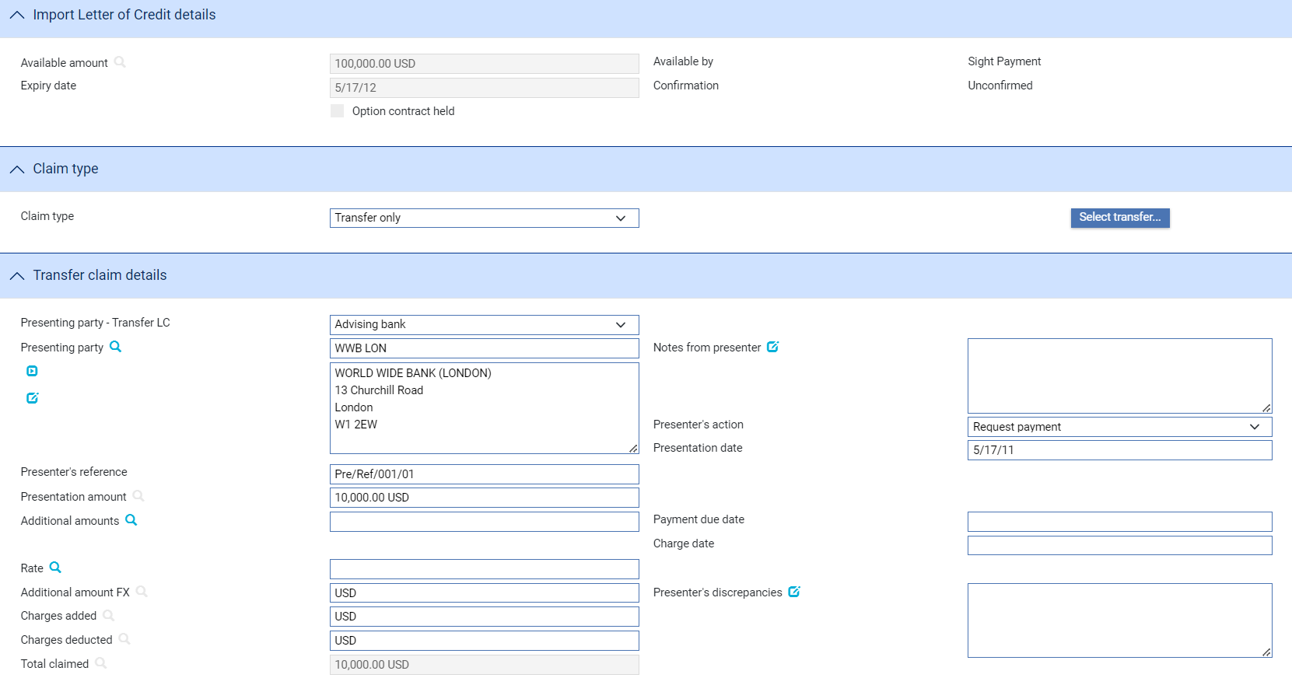 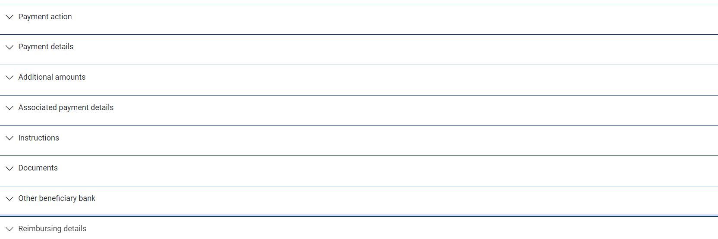

If you select 'Invoice Subst' two panes are displayed for the input of payment details - the Transfer Claim Details pane which allows you to enter details of the payment for the transfer letter of credit; and the Main Claim Details pane which allows you to enter details of the payment for the parent letter of credit.

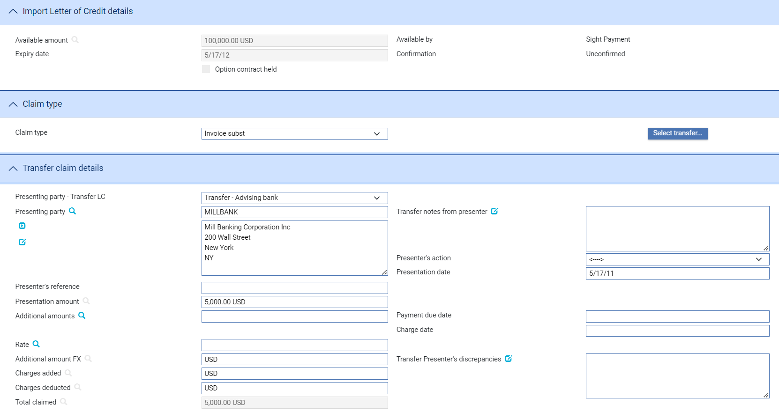 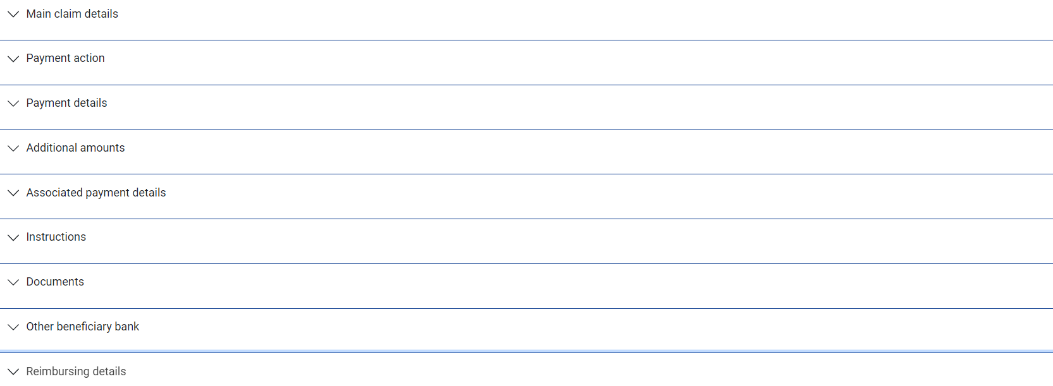

For the transfer letter of credit use the Other Beneficiary Bank field to identify the party the presenter of the transfer letter of credit wants you to pay (if other than the presenter); and the Account field to identify the number of the account to be credited in favour of the bank identified in the Other Beneficiary Bank field.

When processing a claim involving invoice substitution two additional payment actions are available:

* ‘Await Replacement Invoices’, which allows you to enter details of the transfer claim during an initial Claim Received event, and details of the first beneficiary’s claim during a subsequent Outstanding Claim event
* ‘Pay from Suspense’, which allows you to enter details of the transfer claim and make payment to the transfer presented from a suspense account during the initial Claim Received event. You can then enter details of the first beneficiary’s claim during a subsequent Outstanding Claim event, when the transfer portion of the funds received from the issuer are used to clear the suspense account

If you select either of these actions, then, once the first beneficiary’s invoices have been received, you can use an Outstanding Claim event to complete the claim, selecting as your payment action ‘Invoices Received’.

1. The system is delivered with a standard set of ‘Presenter’s actions’ and ‘Payment actions’ which will typically cover the required processing for claims and documentary presentations. However, depending on your bank’s internal processes and requirements, it may be necessary to create additional Presenter’s and Payment actions that are more appropriate to your workflow for transfer letters of credit.

Where this is required, your bank can use System Tailoring to define its own Parameter set based Presenter's actions and Payment actions for Import letters of credit and additionally, create Transfer presenter's actions and Response actions as required. A code and description can be entered for each of these actions together with the associated underlying payment ‘behaviour’ type, such as *General request, Pay, Reject, or Pay at maturity* which then determines the subsequent processing of the payment when the action is selected.

See the System Tailoring Guide – Trade Innovation for instructions on defining additional payment actions.

If your system is configured to support purchase orders, the Purchase Orders button is displayed in the Main Claim Details pane, and accesses a window used to enter purchase order details.

# Making Changes to a Transfer Letter of Credit

For transfer letters of credit amendments can be done independent of the amendments for the first beneficiary, using a Transfer LC - Amend event. This allows your bank to wait for the second beneficiary's approval or rejection of the amendment.

If, when amending a transfer letter of credit you check the Seek Beneficiary Approval flag, then the amendment does not take effect until the beneficiary's approval has been obtained and recorded in the system.

The functionality of the Transfer LC - Amend event allows you to make all the changes that are likely to be required in the normal course of business at the request of the applicant, and which may require beneficiary approval. The system includes an Adjust event, which contains additional functionality to allow you to make changes to all the information recorded for a transaction, with the exception of your bank's reference number for the transaction, and the status of a transaction's master record.

The Transfer LC - Adjust event is designed to allow you to make changes where you need to alter details but do not need to notify other parties.

This functionally is intended to allow you to correct mistakes, and should be used cautiously. If you make any changes using this functionality, you should ensure that the proper reconciliations are carried out.

## Amending a Transfer Letter of Credit

The transfer letter of credit is amended from within the parent letter of credit. In the Master Summary window for the parent letter of credit select 'Transfer LC - Amend' from the Create New Event drop-down list and click **Create**. The system opens the event at either a Log step or Input step. Depending on how your system is configured, panes and fields available in log steps can be tailored for each data capture step. See the *SDK - Screen Tailoring Guide – Trade Innovation* for details.

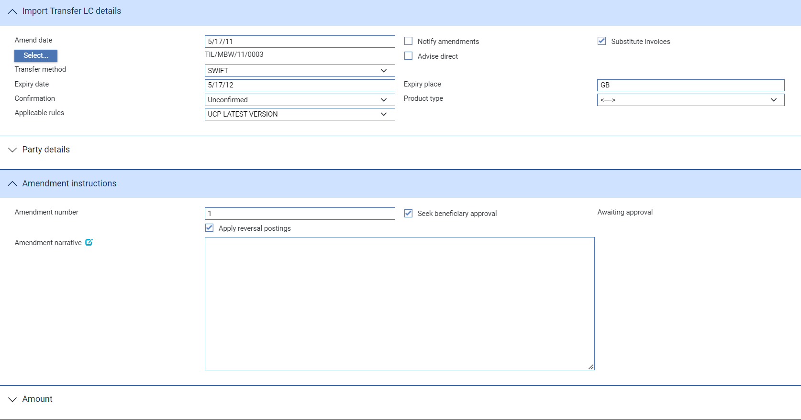 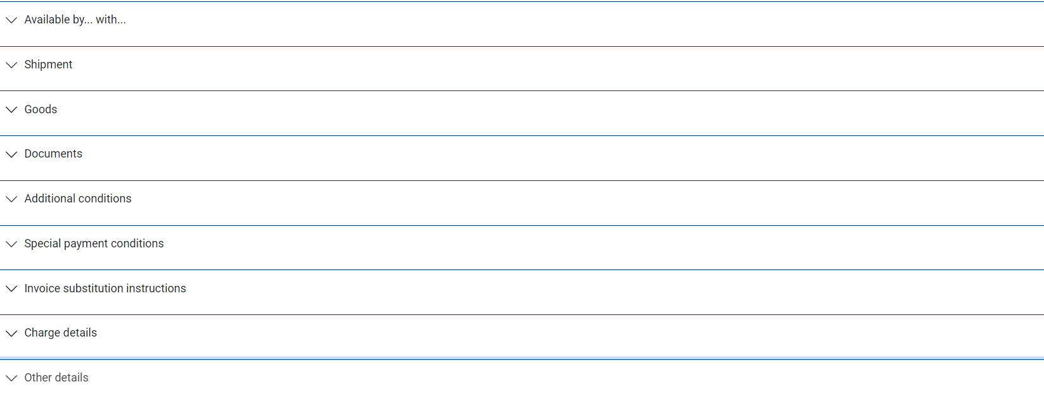

The same window is used by the Adjust event, but with additional panes.

The Select button allows you to select the transfer letter of credit to be amended (see page 15). The Changes button allows you to display any changes made during the event.

If the parent letter of credit has only one transfer letter of credit associated with it, the system displays information for it as the Amend event is opened. If the parent has more than one transfer letter of credit, the Select button permits you to identify the one you wish to amend.

Depending on how your system is configured, the Amendment Narrative field may be positioned on its own in an Amendment Narrative pane. (This is controlled by the AmendAdjustEventScreenlayout system option.)

The window displays a sub-set of the information already input for the transaction, which you can overtype. Your bank can configure the event so that you cannot amend the content of the Goods Description, Documents Required and Additional Conditions fields. (This is controlled by the ProtectFieldsGoodsCondDocsOnAmend system option.)

The following additional fields are present:

|  |  |
| --- | --- |
| Field | What to Enter |
| Amend Date | The date of the amendment. |
| Apply Reversal Postings | Shown only if the DoNotApplyReversalPostings system option in the system administration application is set to No. Leave it checked if your bank has set up reversal postings for the letter of credit Amend event and wishes to apply them when the event is released. |
| Seek Beneficiary Approval | Check this box if beneficiary approval is required for the amendment.  This field is checked by default. However, when Branch general system option ‘DoNotSeekBeneficiaryApproval’ is set to ‘Yes’, the default value of this field is unchecked. The system option only changes the default state of the field but the field can still be updated within the transaction. |
| Amendment Narrative | Information about the amendment. |

You can enter a new amount in one of two ways:

* Use the Increase/Decrease field to indicate whether the amendment involves an increase or a decrease, then enter the amount by which the letter of credit is to be increased or decreased into the Increase/Decrease Amount field
* Overtype the existing value in the LC Amount field

## Recording the Beneficiary's Response

To enter details of the beneficiary's response for transfer letter of credit, in the Master Summary window for the parent letter of credit select 'Transfer LC - Ben Response Amend' from the Create New Event drop-down list and click **Create**. The system opens the event at either a Log step or Input step. Depending on how your system is configured, panes and fields available in log steps can be tailored for each data capture step. See the *SDK - Screen Tailoring Guide – Trade Innovation* for details.

If there is only one Amend event awaiting a beneficiary response, the system retrieves it and displays its reference. If the letter of credit has more than one Amend event awaiting beneficiary response, then the Select button permits you to select the one to which the beneficiary's response relates.

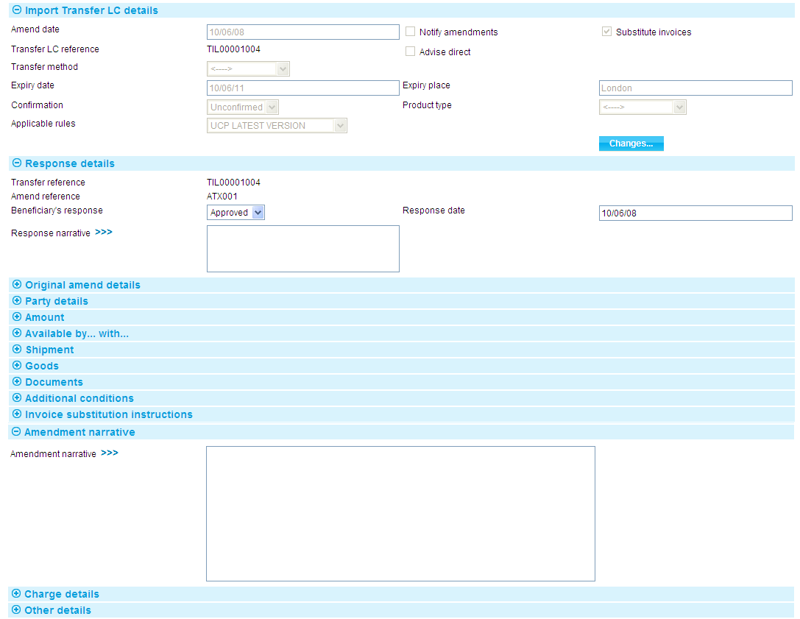

The View event changes menu allows you to display any changes made during the event.

As with the Amend event your system may be configured so that the Amendment Narrative field is positioned on its own in an Amendment Narrative pane. (This is controlled by the AmendAdjustEventScreenLayout system option.)

Your bank can configure the event so that you cannot amend the content of the Goods Description, Documents Required and Additional Conditions fields. (This is controlled by the ProtectFieldsGoodsCondDocsOnAmend system option.)

In the Response Details pane select 'Approved' in the Beneficiary's Response field if the beneficiary has approved the amendment or 'Rejection' if the beneficiary has not agreed to it. Use the Response Narrative field to enter any additional information included with response, such as the reasons for a rejection.

## Adjusting a Transfer Letter of Credit

With the appropriate master record open, in the Master Summary window select 'Transfer LC - Adjust' from the Create New Event drop-down list and click **Create**. The system opens the event at either a Log step or Input step. Depending on how your system is configured, panes and fields available in log steps can be tailored for each data capture step. See the *SDK - Screen Tailoring Guide – Trade Innovation* for details.

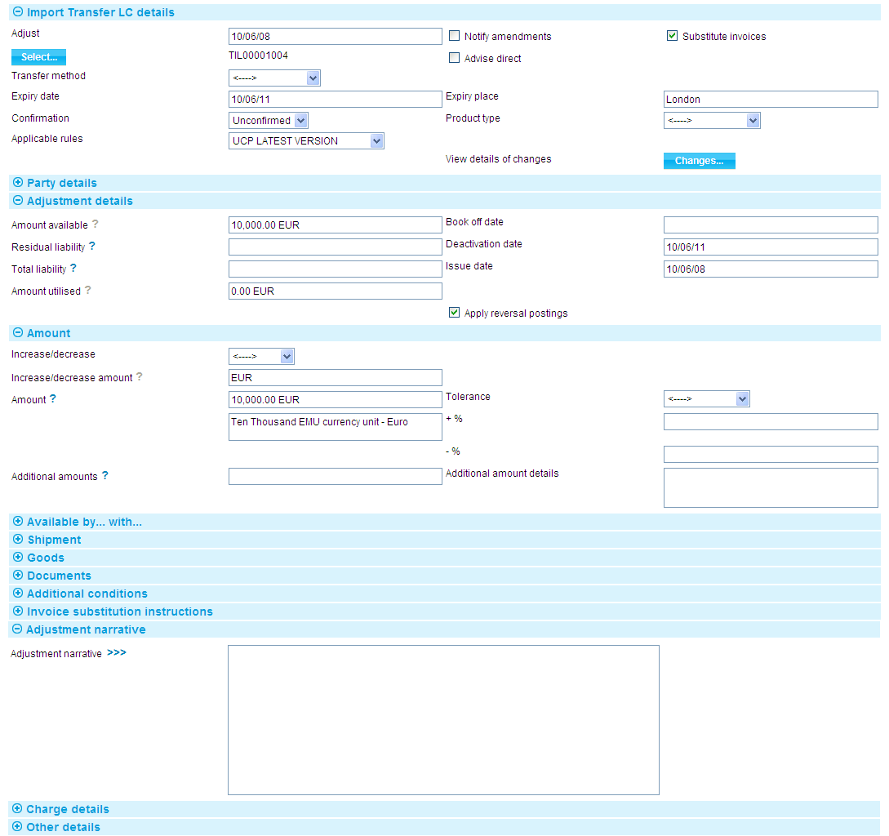

The Select button allows you to select the transfer letter of credit to be amended (see page 15). The Changes button allows you to display any changes made during the event.

The window displays a sub-set of the information already input for the transaction, which you can overtype.

Depending on how your system is configured, the Amendment Narrative field may be positioned on its own in an Amendment Narrative pane. (This is controlled by the AmendAdjustEventScreenlayout system option.)

During an Adjust event you can view charges and add optional charges, but cannot edit existing charges. To change charges, use a Maintain Charges event.

|  |  |
| --- | --- |
| Field | What to Enter |
| Adjust | The date the adjustment was made. |
| Adjustment Narrative | A narrative identifying the nature of and reason for the adjustment. |
| Amount Available | The current available amount. |
| Residual Liability | The system displays the outstanding liability amount for the master record, excluding the amounts of any presentations. Use this field to overwrite those shown on the master summary if, for any reason, the master figures are incorrect. |
| Total Liability | The system displays the outstanding liability amount for the master record, including that of accepted drafts not yet paid. Use this field to overwrite those shown on the master summary if, for any reason, the master figures are incorrect. |
| Book Off Date | The system displays the letter of credit's book-off date, which you can amend. The system will then book off the letter of credit when the new book-off date is reached. |
| Deactivation Date | The system displays the date on which the letter of credit will become inactive (after its expiry date and any days grace period has elapsed). You can amend this date.  See the System Tailoring User Guide – Trade Innovation for the days grace period, which may be different for master records expiring locally and those expiring abroad. |
| Issue Date | The letter of credit's issue date. |
| Amount Utilised | The amount of the letter of credit utilised so far. |
| Apply Reversal Postings | Leave checked if your bank has set up reversal postings for the import letter of credit Adjust event and wishes to apply them when the event is released.  If the DoNotApplyReversalPostings system option in the system administration application is set to yes, then the Apply Reversal Postings check box is not available on this event. |

You can enter a new amount in one of two ways:

* You can use the Increase/Decrease field to indicate whether the amendment involves an increase or a decrease, then enter the amount by which the letter of credit is to be increased or decreased into the Increase/Decrease Amount field. The system calculates and displays the new amount.
* Alternatively, overtype the existing value.

# Cancelling a Transfer Letter of Credit

A transfer letter of credit can be cancelled at any time between the release of the event that created it and expiry using a Transfer LC -Cancel event.

If, in this event, you check the Seek Beneficiary Approval flag, then the cancellation does not take effect until the beneficiary's approval has been obtained and recorded in the system.

## Cancelling a Transfer Letter of Credit

To cancel a transfer letter of credit, in the Master Summary window for the parent letter of credit select 'Transfer LC - Cancel' from the Create New Event drop-down list and click **Create**. The system opens the event at either a Log step or Input step. Depending on how your system is configured, panes and fields available in log steps can be tailored for each data capture step. See the *SDK - Screen Tailoring Guide – Trade Innovation* for details.

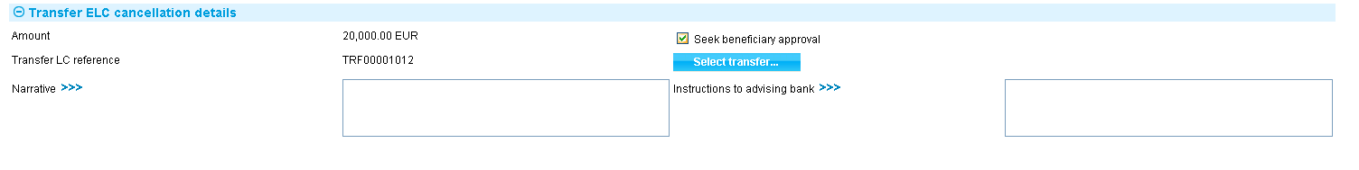

The Select button allows you to select the transfer letter of credit to be amended (see page16).

If the parent letter of credit has only one transfer letter of credit associated with it, the system displays information for it as the window is opened. If the parent has more than one transfer letter of credit, the Select Transfer LC button permits you to identify the one you wish to cancel.

If beneficiary approval is required before the cancellation can take place check the Seek Beneficiary Approval field. Use the narrative fields to enter the reasons for the cancellation and any instructions to the next advising bank or the reimbursing bank regarding the cancellation.

## Recording the Beneficiary's Response

To enter details of the beneficiary's response to cancel a transfer letter of credit, in the Master Summary window for the parent letter of credit select 'Transfer LC - Ben Resp Cancel' from the Create New Event drop-down list and click **Create**. The system opens the event at either a Log step or Input step. Depending on how your system is configured, panes and fields available in log steps can be tailored for each data capture step. See the *SDK - Screen Tailoring Guide – Trade Innovation* for details.

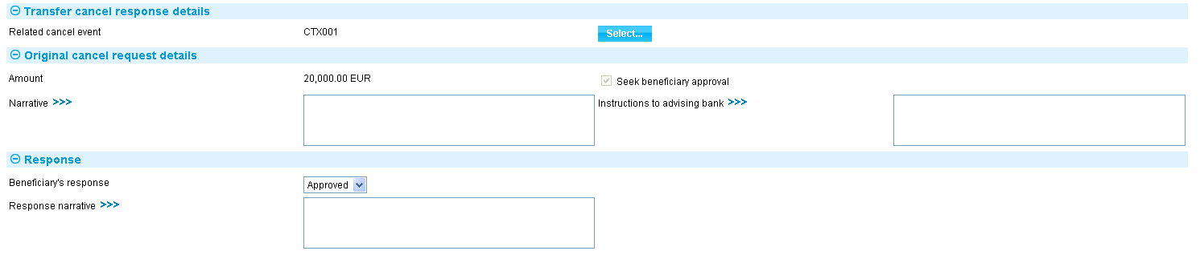

If there is only one transfer cancellation event awaiting a beneficiary response, the system retrieves it and displays its reference. If there is more than one transfer cancellation event awaiting beneficiary response, then the Select button permits you to select the one to which the beneficiary's response relates.

Use the Beneficiary's Response field to indicate whether the beneficiary has approved or rejected the cancellation. Use the Response to Beneficiary field to enter any additional information included with the response, such as the reasons for a rejection.